NAME: Siaruli Precious Sedzani
STUDENT NO:ST10453924
1. Introduction
In today’s digital world, managing personal finances has become increasingly important due to rising living costs and financial responsibilities (Goodbudget.com, 2025). Budgeting applications provide users with tools to monitor their income, track expenses, and improve financial decision-making (EveryDollar App, 2026). This research investigates three different personal budgeting applications: Goodbudget, EveryDollar, and Spendee. The aim is to evaluate their functionality, usability, strengths, weaknesses, and unique features. The findings will be used to guide the development of a new budgeting application2. Application 1: Goodbudget
2.1 Overview
Goodbudget is a budgeting application based on the envelope budgeting method, where users divide their money into digital “envelopes” representing different spending categories instead of linking bank accounts, and then manually allocate their income into these envelopes for various expenses (Goodbudget.com, 2025; Experian, 2026).

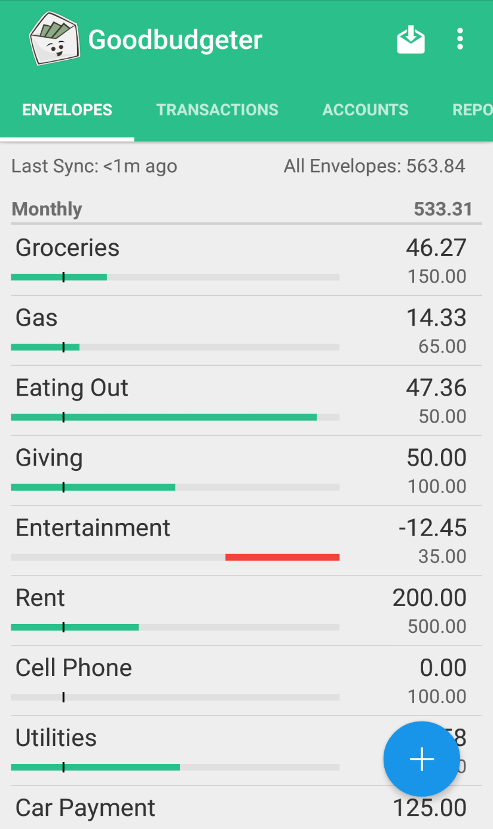
Screenshot 1: Envelope Budget Screen
Description:
This screen shows different budget categories represented as envelopes such as groceries, rent, and transport. Each envelope displays the allocated amount and remaining balance.

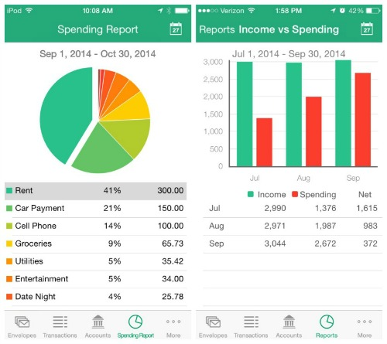
Screenshot 2: Spending History
Description:
This screen lists all recorded transactions with details such as amount, category, and date. It helps users keep track of their spending habits.

📸 Screenshot 3: Budget Overview
Description:
This screen provides a summary of total income, expenses, and remaining balance. It allows users to see their overall financial position.
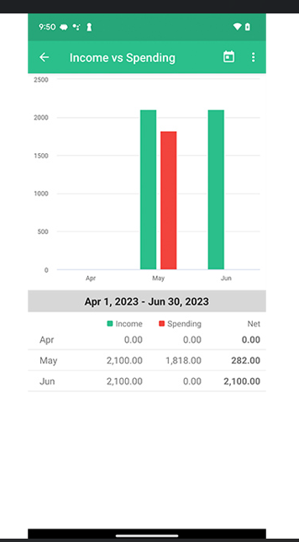

2.2 Strengths
- Simple budgeting method
- No bank linking required
- Good for beginners
2.3 Weaknesses
- Requires manual entry
- Limited automation
2.4 Innovative Features
- Envelope budgeting system
- Cross-device syncing

3. Application 2: EveryDollar
Overview
EveryDollar is a personal budgeting app that focuses on zero-based budgeting, a method where every dollar of income is assigned a specific purpose, such as expenses, savings, or debt repayment. The app allows users to create monthly budgets, track spending in real-time, and adjust their plans as needed. It also offers features like visual spending summaries, transaction tracking, and customizable categories, making it easy to see where money is going. By helping users plan, monitor, and control their finances, EveryDollar encourages better financial habits, prevents overspending, and supports long-term financial goals. Its simple design and clear structure make it suitable for both beginners and experienced budgeters who want to take control of their money.

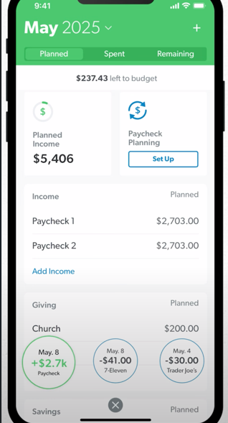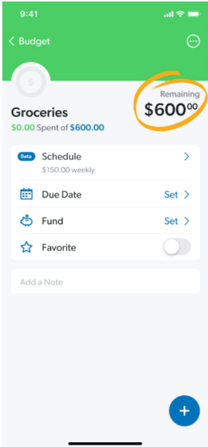
Screenshot 1: Monthly Budget Planner
Description:
This screen displays the user’s income and expense categories, allowing them to assign specific amounts to each category. By doing so, the app ensures that every dollar is planned, helping users stick to a zero-based budget. The interface is intuitive and organized, making it easy to see the full budget at a look and make adjustments as needed.

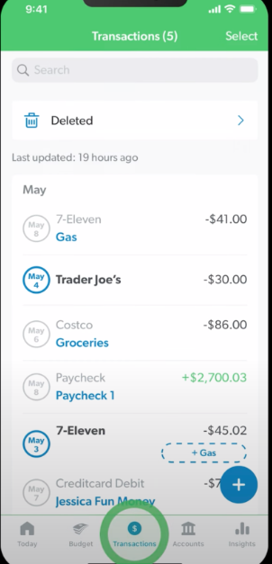
Screenshot 2: Expense Tracking
Description:
This screen shows all the transactions entered by the user, allowing them to track spending in real time. Users can see individual expenses, categorize them, and monitor how their spending compares to their budget. The interface is designed to be clear and easy to use, helping users quickly identify areas where they might overspend or need to adjust their budget.

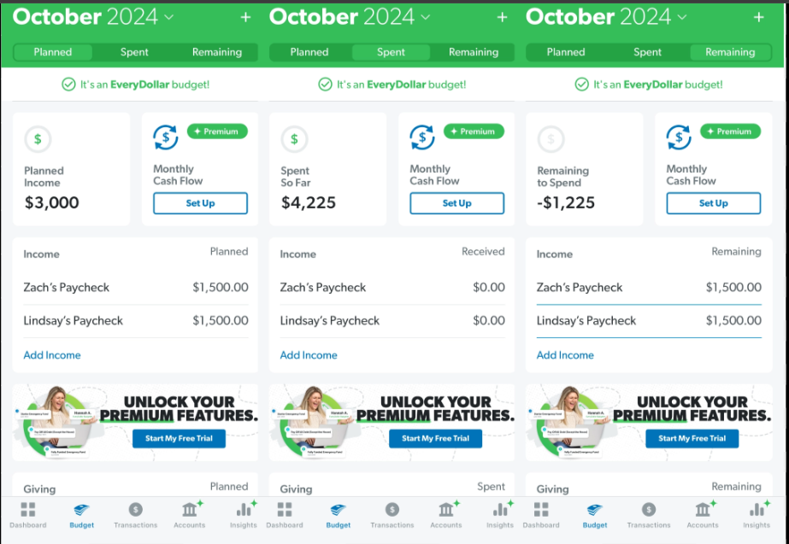 Screenshot 3: Budget Summary
Description:
This screen provides an overview of total planned versus actual spending, allowing users to see how closely they are following their budget. It highlights areas where spending may be over or under budget and helps users make informed adjustments. The clear summary makes it easy to stay on track with financial goals and maintain control over money management.

3.2 Strengths
- Structured budgeting approach
- Easy to understand
- Encourages discipline
3.3 Weaknesses
- Limited free features
- Requires manual updates
3.4 Innovative Features
- Zero-based budgeting system
- Monthly planning focus

4. Application 3: Spendee
4.1 Overview
Spendee is a modern budgeting app designed to help users understand and manage their finances more effectively by showing financial activity in one place and using clear charts and visual summaries of income and expenses (Spendee.com, 2026; Apple App Store, 2025). The app emphasizes visual financial tracking, including colorful graphs and infographics that reveal spending patterns and trends over time, which helps users see where their money is going, recognize overspending, and make better financial decisions (Apps.apple.com, 2025). One of Spendee’s key features is shared wallets, which allows multiple people — such as family members, friends, or roommates — to manage budgets together and view who spent what, making joint budgeting easier (Spendee.com, 2026). Spendee also supports customizable budget categories and can connect to bank accounts so transactions are automatically tracked and categorized (Spendee.com, 2026). With its intuitive interface and focus on visual feedback, Spendee makes budgeting easy and engaging, helping users develop better financial habits and work towards both short- and long-term financial goals (Spendee.com, 2026; Apple App Store, 2025).
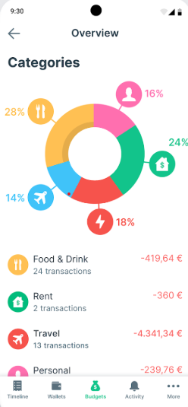
Screenshot 1: Dashboard
Description:
This screen shows the user’s account balances and spending summaries in an easy-to-read format. Using colorful charts and graphs, it provides a visual overview of income, expenses, and budget progress. Users can quickly see where their money is going, track trends over time, and identify areas that may need adjustment to stay on track with their financial goals.

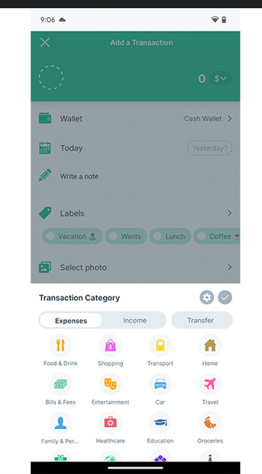 Screenshot 2: Wallets Feature
Description:
This screen shows the wallets feature, which lets users create separate wallets for different purposes, such as personal spending, shared expenses with family or friends, or savings goals. Each wallet tracks its own income and expenses, making it easy to organize money, monitor balances, and manage budgets for specific needs. This feature is especially useful for group budgets or planning for multiple financial goals, helping users stay organized and in control of their finances.

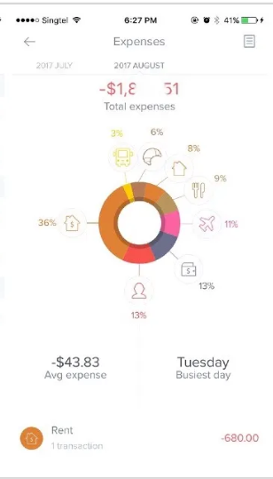 Screenshot 3: Expense List
Description:
This screen displays a list of all transactions, showing the amount, category, and date for each entry. It allows users to quickly review spending habits, track where their money is going, and ensure expenses are properly categorized. The clear layout makes it easy to monitor daily spending and helps users stay on top of their budget goals.

4.2 Strengths
- Attractive interface – Easy-to-use design with visual appeal.
- Visual insights – Charts and graphs make spending patterns clear.
- Shared budgeting – Allows multiple users to manage budgets together.
4.3 Weaknesses
- Some features require payment – Not all functions are free.
- Can be complex for new users – Learning all features may take time.
4.4 Innovative Features
- Shared wallets – Multiple users can contribute to or track the same budget.
- Visual dashboards – Colourful charts give a clear overview of finances.

5. Infographic Comparison
The three budgeting applications—Goodbudget, EveryDollar, and Spendee—differ significantly in their design approach, budgeting philosophy, and level of automation. Goodbudget focuses on the envelope budgeting system, which encourages users to manually assign income into categories. This makes it highly suitable for users who prefer a disciplined, hands-on approach to money management, but it can feel time-consuming due to the lack of automation.
EveryDollar, on the other hand, is built around zero-based budgeting. This means every unit of income must be assigned a purpose before the month begins. Compared to Goodbudget, EveryDollar provides a more structured planning experience with a stronger focus on monthly financial discipline. However, it still requires manual transaction entry unless the premium version is used, which can limit convenience for some users.
Spendee differs from both apps by prioritising automation and visualisation. It allows users to link bank accounts, automatically categorise transactions, and view their financial data through colourful charts and dashboards. This makes it more appealing to users who want real-time financial tracking with minimal manual input. Additionally, its shared wallet feature makes it more suitable for group or household budgeting compared to the other two apps.
Overall, Goodbudget is best for simple manual budgeting, EveryDollar is ideal for structured financial planning, and Spendee is strongest in automation and visual financial insights. Each app serves a different type of user depending on their financial habits and preferences.

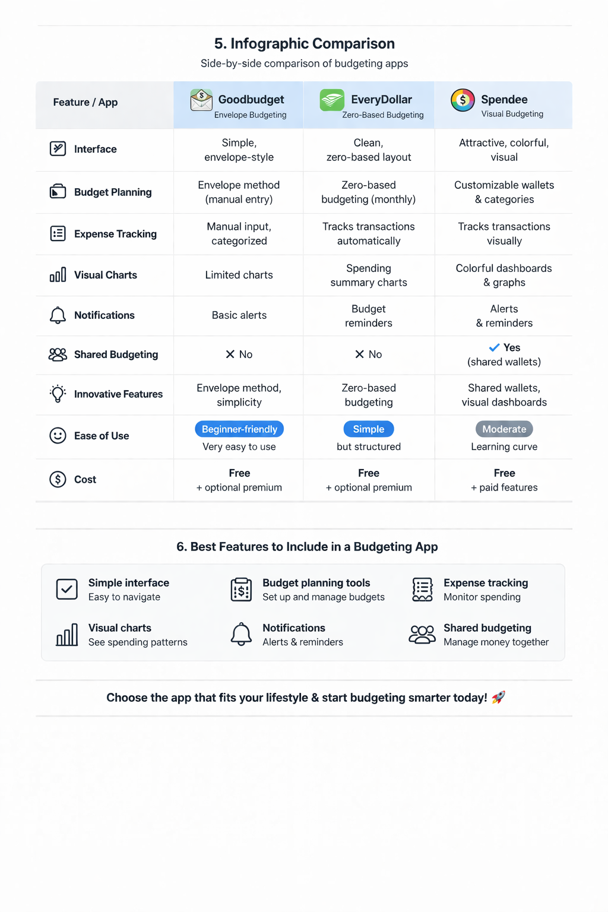
comparison between:
- Goodbudget
- EveryDollar
- Spendee

6. Best Features to Include
- Simple interface
- Budget planning tools ,Expense tracking ,Visual charts Notifications ,Shared budgeting
- Based on the analysis of the three applications, several key improvements can be identified for the development of a new and more effective budgeting application. Firstly, the app should combine both manual and automated budgeting features. This would allow users who prefer control over their finances to manually input data, while also giving other users the option to link bank accounts for automatic tracking.
- Secondly, the application should include a simple and beginner-friendly interface. Many users struggle with overly complex financial tools, so the design should prioritise clarity, minimal steps, and easy navigation. A clean dashboard with clear summaries of income, expenses, and savings would improve usability.
- Thirdly, strong visualisation tools should be included. Charts, graphs, and progress bars can help users quickly understand their spending habits and financial progress. This feature is especially useful for users who prefer visual learning rather than reading detailed financial reports.
- In addition, the app should support goal-setting features such as savings targets, debt repayment plans, and monthly budget limits. Notifications and reminders should also be included to help users stay on track and avoid overspending.
- Finally, a shared budgeting feature should be integrated, allowing multiple users such as families, couples, or roommates to manage shared expenses together. This would improve collaboration and financial transparency.

7. Conclusion
The analysis shows that many different budgeting apps all work in their own special ways to help people manage their money. Each app has its own style, and some focus on being easy to use, while others focus on helping people organize their money in a clear way or showing them useful charts and visuals about their spending and saving. From looking at all of these different apps, it is clear that if you put together the best parts—keeping things simple, giving a good structure, and showing clear visual feedback—you can make a budgeting app that works better than the others. This kind of app would help people keep track of their money, plan their spending, and stay in control of their finances in a way that is easy to understand and follow.
Furthermore, budgeting applications play an increasingly important role in modern society as individuals face rising living costs and financial pressure. By using digital tools, users are able to gain better control over their spending habits and develop healthier financial behaviours over time. A well-designed budgeting application can therefore contribute not only to short-term financial organisation but also to long-term financial stability and planning.
A future budgeting app that combines the strengths of Goodbudget, EveryDollar, and Spendee would provide a more complete solution for users with different needs and financial goals.

8. References
Goodbudget.com. (2025) Budget with a why – Goodbudget. Available at: https://goodbudget.com/ (Accessed: 23 March 2026).
EveryDollar. (2026) EveryDollar: Budget Management App. Available at: https://apps.apple.com/us/app/everydollar-personal-budget/id942571931 (Accessed: 23 March 2026).
Spendee.com. (2026) Spendee – Money Manager & Budget Planner. Available at: https://www.spendee.com/ (Accessed: 23 March 2026).

